What do you think is the key ingredient for a productive and harmonious work environment?
In your opinion, what skill is essential for building strong relationships and collaboration among team members?
What do you think is the most critical aspect of creating a positive and efficient workplace culture?

Here is the answer:
https://www.istockphoto.com/photo/effective-communication-street-sign-gm155283212-19017579?phrase=effective+communication
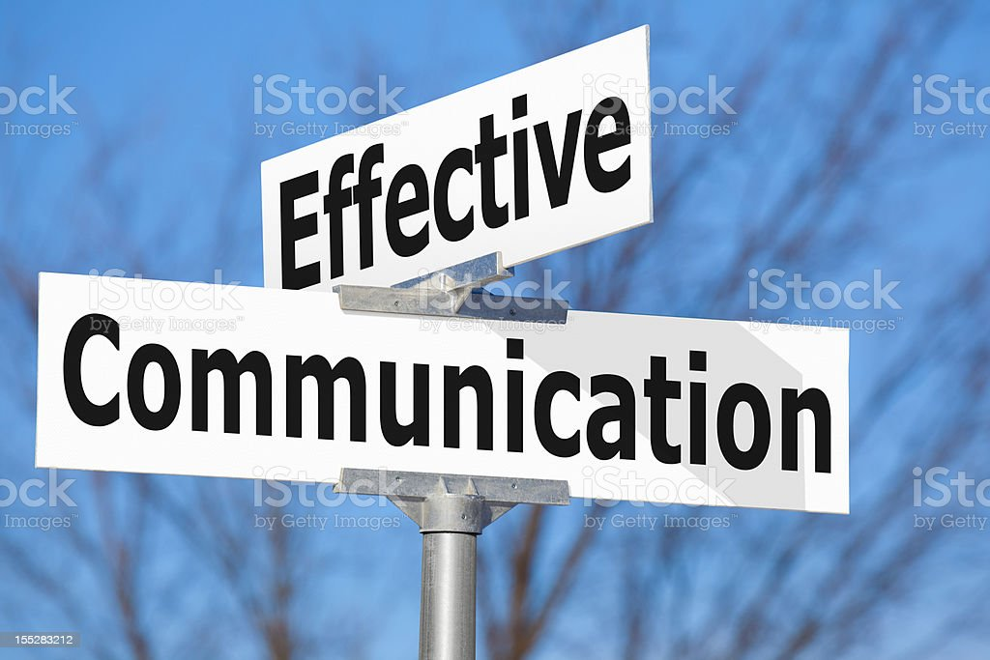

INTRODUCTION

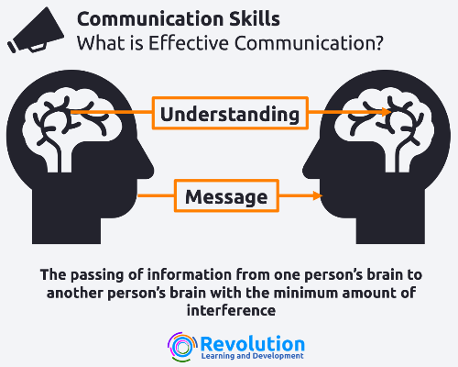

INTODUCTION
- presentation of views in a way best understood by reciever
-Efficient information exchange for purposeful outcomes

BENIFITS OF EFFECTIVE COMMUNICATION IN WORKPLACE
1.Builds healthy work relationships.
2.Bring more innovatiobns
3.Reduces conflicts and misunderstanding
4.Better teamwork and collaboration

https://www.rocket.chat/blog/workplace-team-communication

TYPES OF COMMUNICATION

VERBAL COMMUNICATION
-usage of words to delivery intended message
-it also involve how those words are used
-tone and pitch play crucial role
- can be face-to-face, over the telephone, via Skype or Zoom, etc.


https://www.linkedin.com/pulse/managing-verbal-communication-workplace-ishimwe-romalice
NON-VERBAL COMMUNICATION
-occurs without the use of words
-gestures, body language, and facial expressions
- conveys emotions, attitudes, and intentions

WRITTEN COMMUNICATION
-uses written words to exchange information
-provides a record of information for reference
-examples:mail,memo,pamphlets,letters etc.

VISUAL COMMUNICATION
-utilizes visual elements to convey information
-act of using photographs, graph,presentation etc
-more helpful to convey ideas and information

https://www.indeed.com/career-advice/career-development/types-of-communication

BARRIERS TO EFFECTIVE COMMUNICATION
1. Attitudinal barriers
-perceptions that stop people from communicating well
2. Behavioral barriers
- behaviours like bias, generalisations and
stereotyping
3. Cultural barriers
-Differences in customs, values, beliefs, and norms
4. Language barriers
- obstacles arising from language differences
5. Environment Barriers

STRATIGIES TO EFFECTIVE COMMUNICATION
- Be Clear and Concise
goal of effective communication is clear, honest and timely information
helps to avoid misunderstandings and confusion
https://www.ringcentral.com/us/en/blog/effective-communication-strategies-in-the-workplace/

-Active listening
practice of preparing to listen, observing verbal and non-verbal messages
https://en.wikipedia.org/wiki/Active_listening

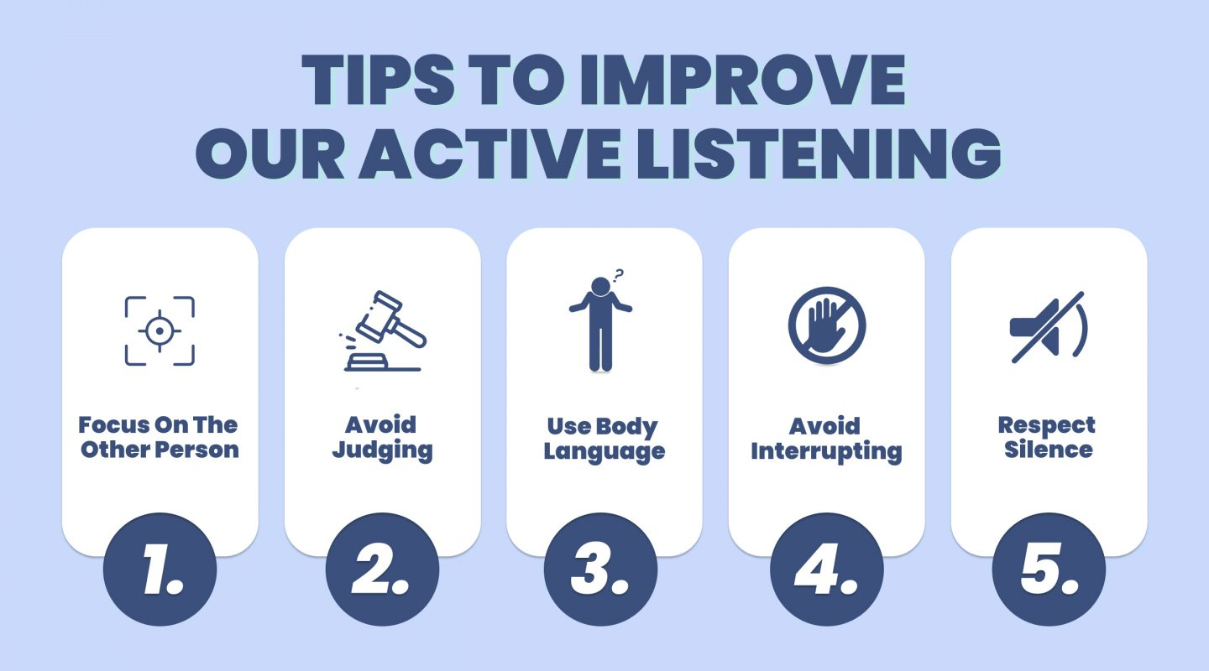

Empathy and Emotional Intelligence:
-Understand and consider the emotions ,perspectives of others.
-Show empathy and respect when communicating sensitive or challenging topics
-Adapt your communication style to match the emotional needs of the situation.
https://en.wikipedia.org/wiki/Empathy

Move with time
-Outdated systems and methods of communication should be pushed out
-use automated and cloud-based electronic solutions
improves communication and increases productivity.

Use Visuals
-utilize charts, graphs, and diagrams to enhance understanding
-Use presentations and visuals to support and reinforce your verbal message

Nurture Two way Communication-strategies
-Seek input and opinions from others to foster collaboration and engagement
-be open to feedback,doubts and critisism
-be accessible for help, guidance, and problem-solving

https://joinblink.com/intelligence/organizational-communication-strategies/

DIFFERENT SCENARIO REQUIRING DIFFERENT COMMUNICATION SKILLS
.Project Management
to ensure shared understanding, alignment, and timely updates

-Stakeholders communication
to inform about project progress, risks, and decisions.
-Presentation
to information accurately and engaging the audience
ensures clarity, understanding, and retention of the presentation content
-Team Collaboration
for sharing of ideas and information
to resolve conflicts or challenges efficiently

